**Introduction**

Increased demand for simplified filing system has high demand focus on security, efficiency and durability. It's essential to develop filing systems with a solid plan, clearly defining the purpose, goals and guidelines. Contract management system helps the users to manage, store and modify the legal document.

**Admin user login**

User can login to the CMS by entering the credentials. Users can access the full interface of CMS, where they can manage features such as Dashboards and Reports, Admin management and document process view, depending on their user permissions.

**Dashboard**

The dashboard features a user management screen that allows users to create new accounts and displays a list of users in a table format.

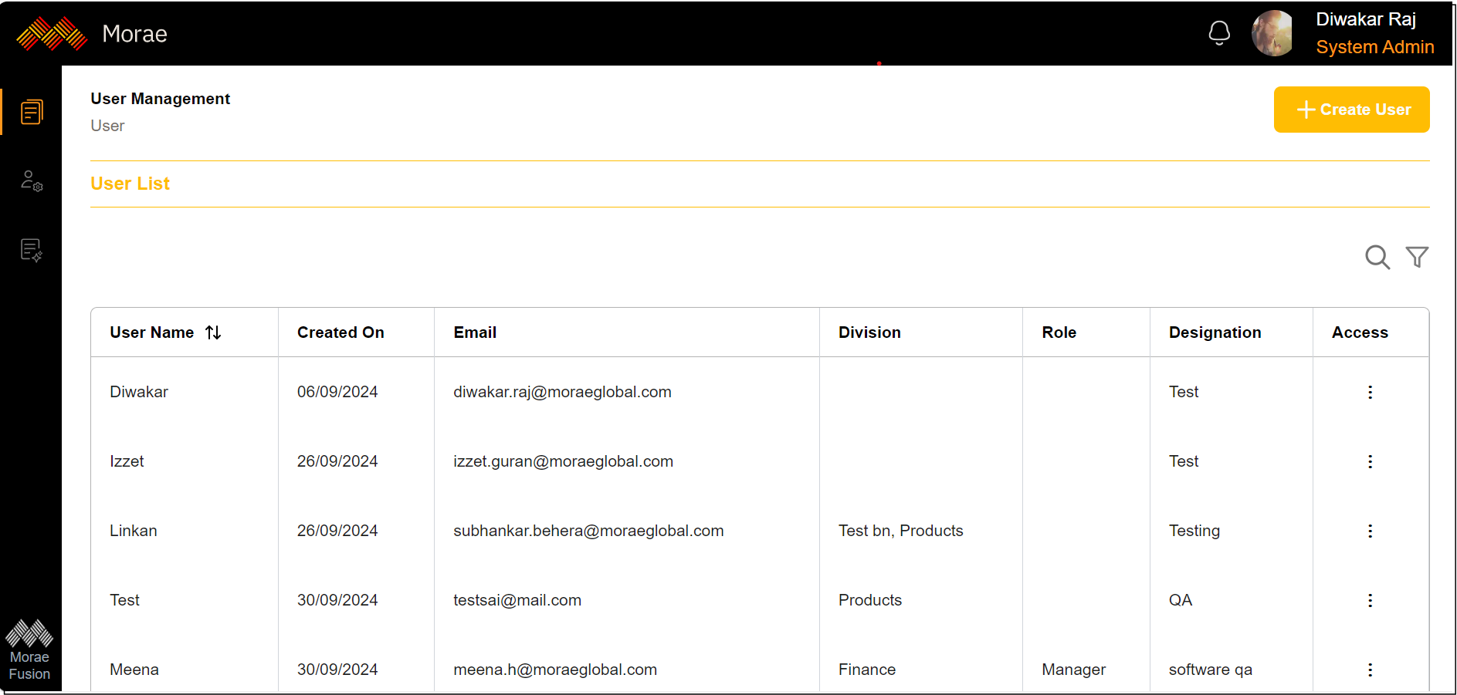

The user list includes columns for Username, Created On, Email, Division, Role, Designation, and Access. The available access options are View, Edit, and Delete.

Users can search for individuals by entering keywords in the search bar, and they can filter the results by Username and Designation.

User can create new users by providing the basic details.

* **First Name, Last Name**: Enter the first name and last name of the user to be created.
* **Email Address:** An email address must be provided.
* **Division:** Division can be selected from dropdown menu.
* **Designation:** Designation need to be provided.
* **Role:** Role of the new user can be selected from the dropdown menu.
* **Region, Country, State, City:** These details can be selected from the dropdown menu.
* **Zip code, Phone number:** These details need to be provided.
* **User Group:** User Group can be selected from the dropdown menu.
* **External:**

After entering click on **Save** for creating new user.

**Report Management**

The report management section allows for the management of the report list and the search reports.

**Report List**

The report list shows the details of each report.

The report list includes Report Name, Report Description, Report Type, Updated Date, and Action. The available actions are to view or delete the report.

**Search**

User can search the report in search section. User can search the report by entering keywords in search bar.

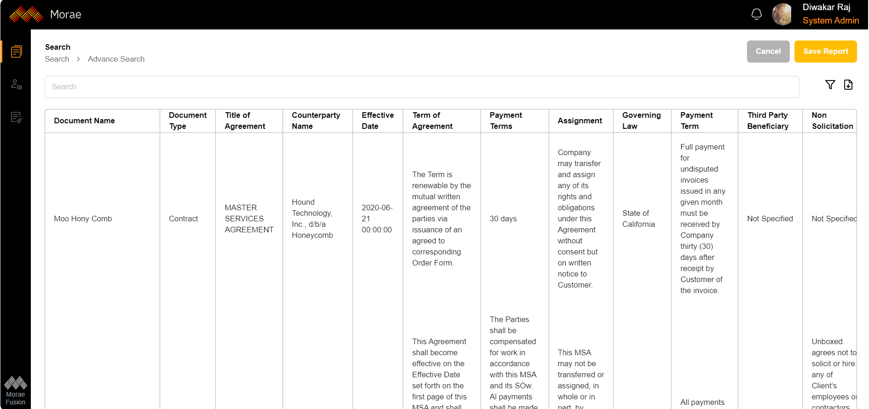

User can save report by clicking on save report.

User can enter Report Name and report description and click on save to save the report.

**Admin**

**Division management**

In division management page user can see the list of divisions and user can create new Division.

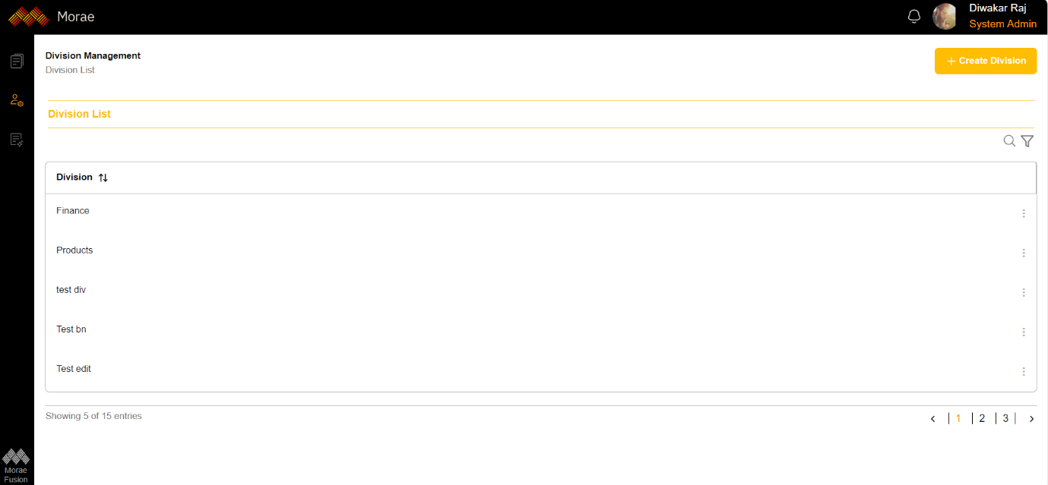

User can search the division by entering keywords in the search bar. User can filter the division list by entering division name.

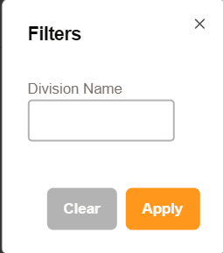

User can click on the three dots to view, edit or delete the division.

**Create division**

User can enter create division for creating new division.

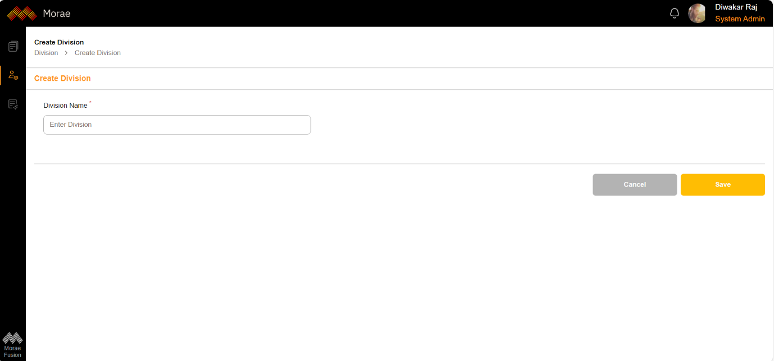

Click 'Save' to save the new division.

**Role management**

In Role management screen user can see the list of role and user can create new role.

The Role list table displays the Role name, Description, Division and Privileges. User can click on the three dots to view, edit or delete the Role.

User can search any role by entering keywords in search bar. User can use filter option to filter the role by entering role and division.

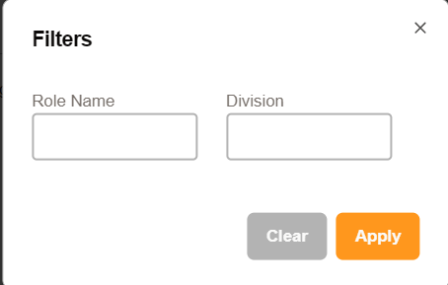

**Create Role**

The user can create a role by clicking on 'Create Role.' There are two sections in this process: 'Role' and 'Set of Privileges.

The role name can be entered in this section, and the division can be selected from the dropdown menu. A description can also be added in the designated section.

The set of privileges includes several subsections: Admin, Document Management, Document, AI, Search, and Reports.

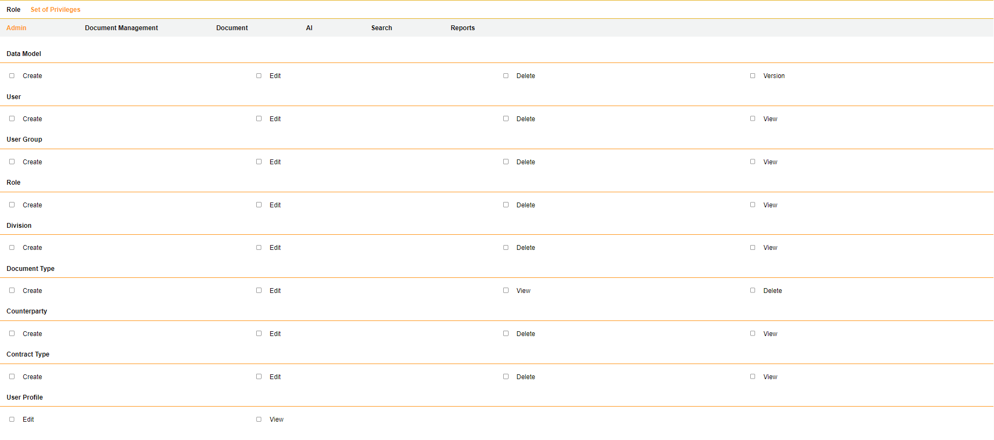

In the Admin privileges section, the user can select the desired privileges to grant to users.

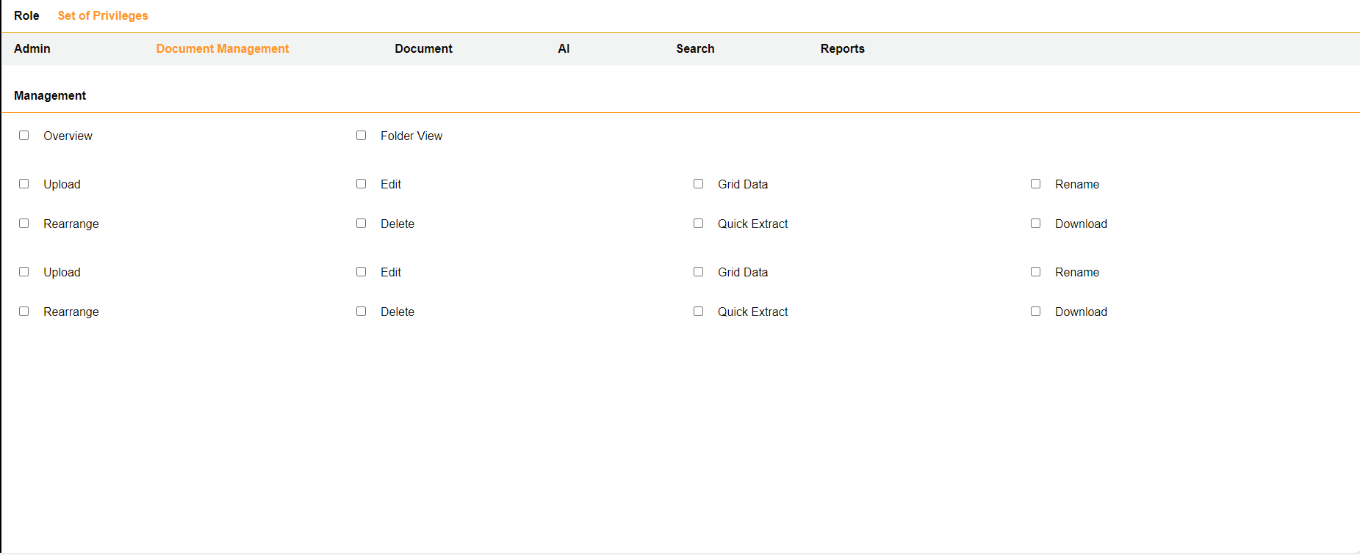

In the Document Management privileges section, the user can select the desired privileges to grant to users.

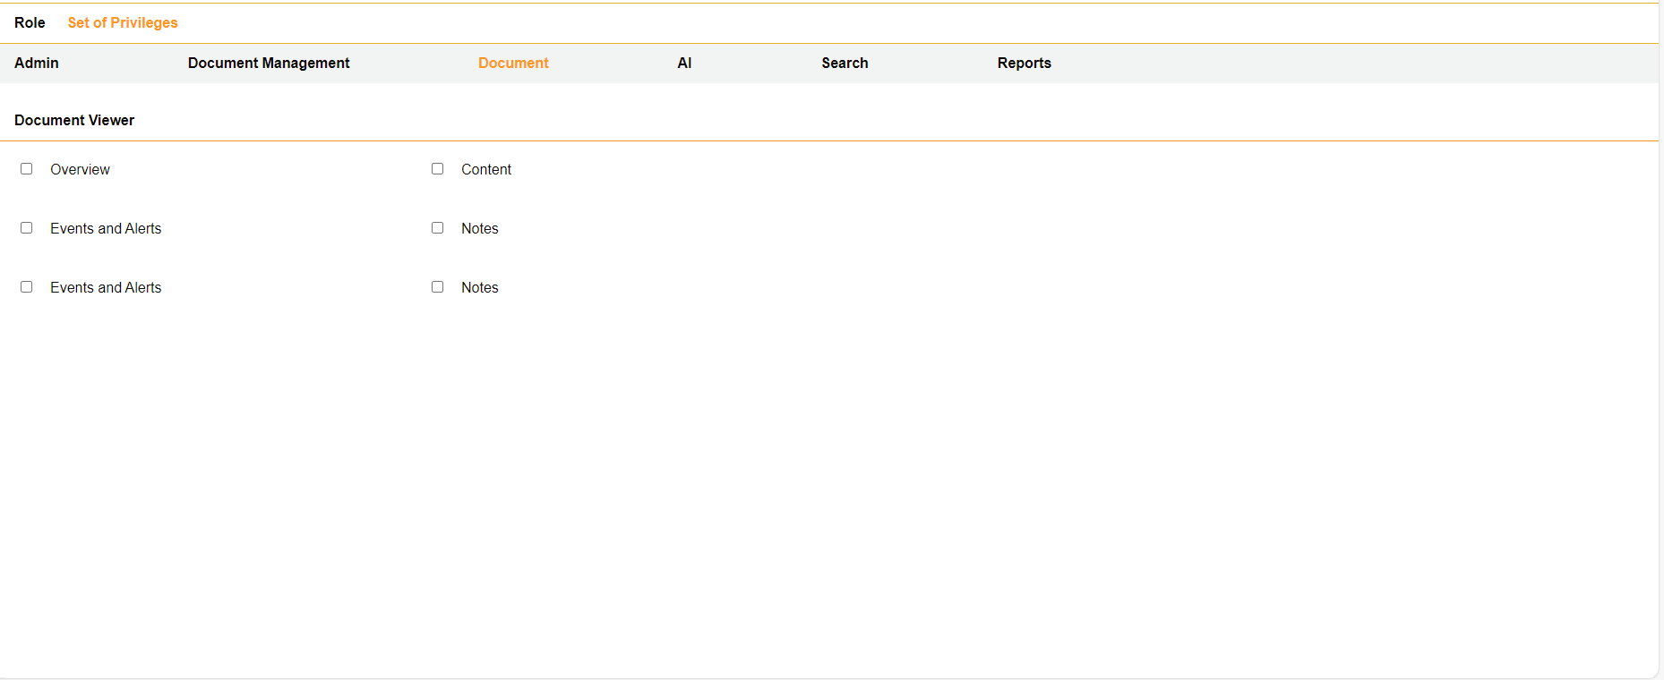

In the Document privileges section, the user can select the desired privileges to grant to users.

In the AI privileges section, the user can select the desired privileges to grant to users.

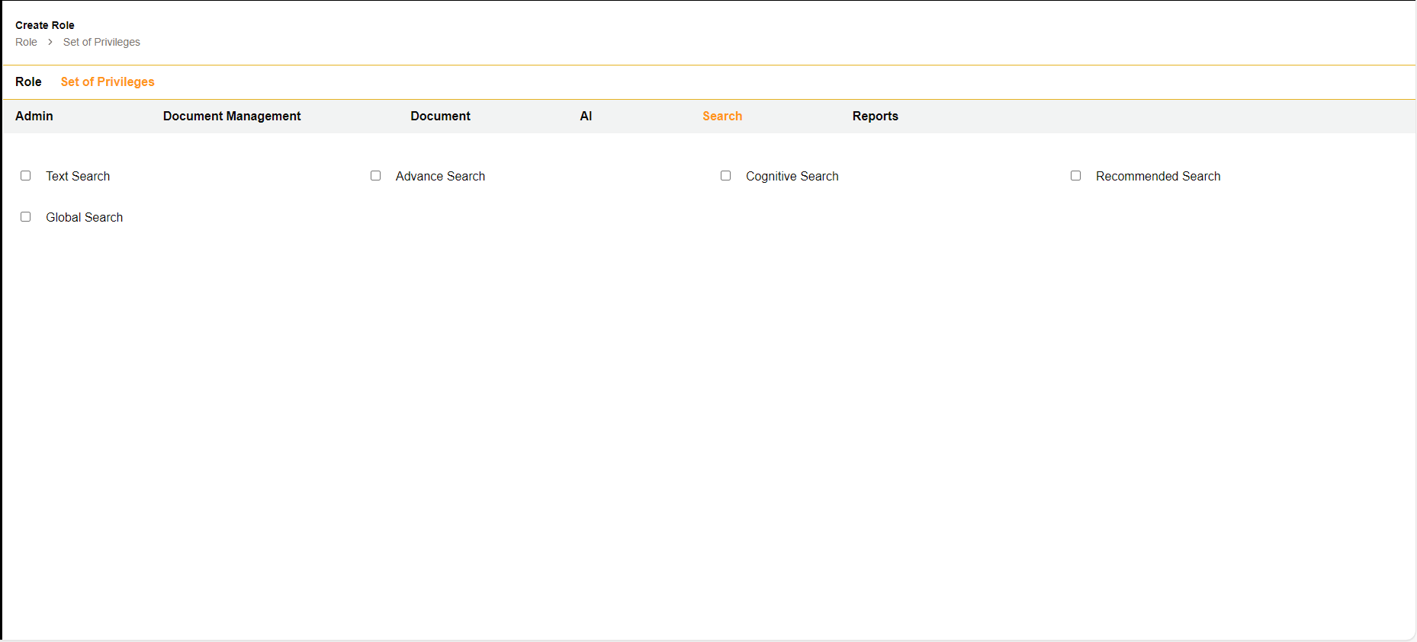

In the Search privileges section, the user can select the desired privileges to grant to users.

In the Reports privileges section, the user can select the desired privileges to grant to users.